DBMS WEEK-3
ORDERS TABLE
STEP 1: CREATE TABLE
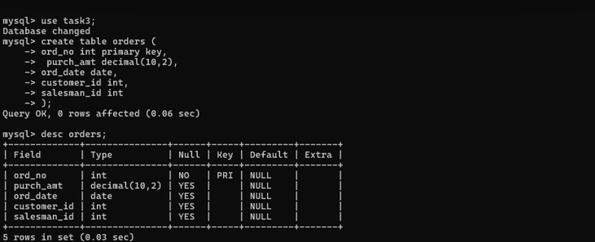

STEP 2: INSERT DATA
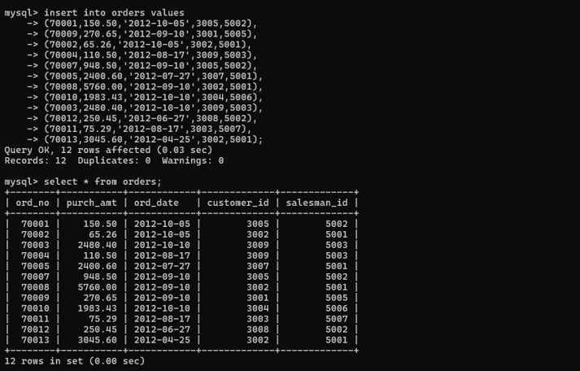

QUESTION 1 - WHERE CLAUSE
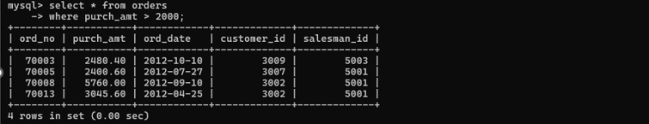
QUESTION 2 - WHERE CLAUSE
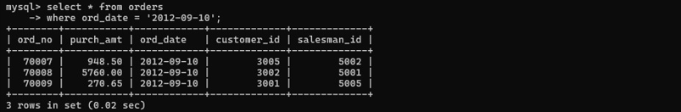
QUESTION 3 - WHERE CLAUSE
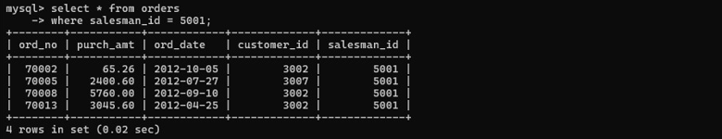
QUESTION 4 - ORDER BY
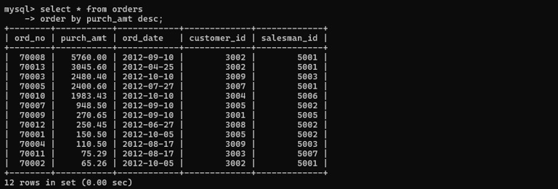

QUESTION: 5 - ORDER BY
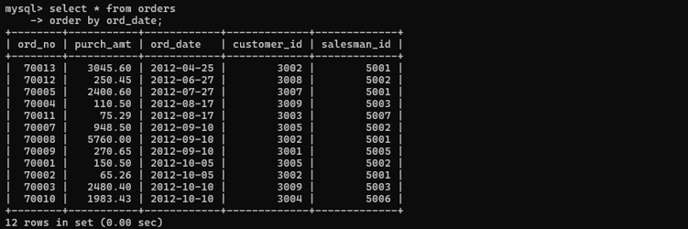
QUESTION :6 -SUM ()
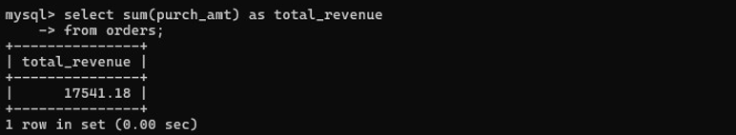
QUESTION :7 – AVG ()
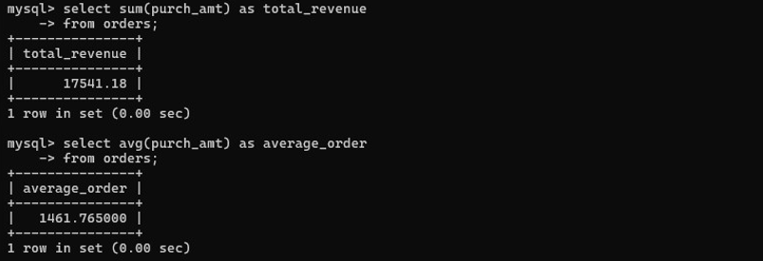
QUESTION 8 – MAX ()
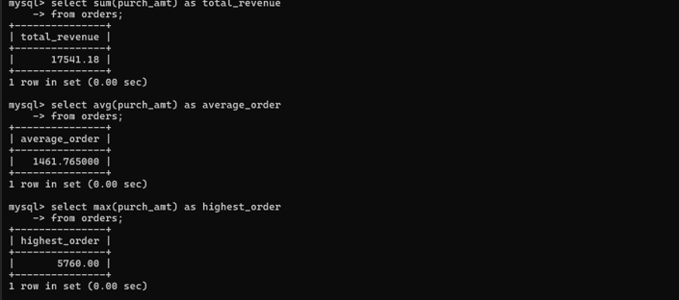
QUESTION 9 - MIN()
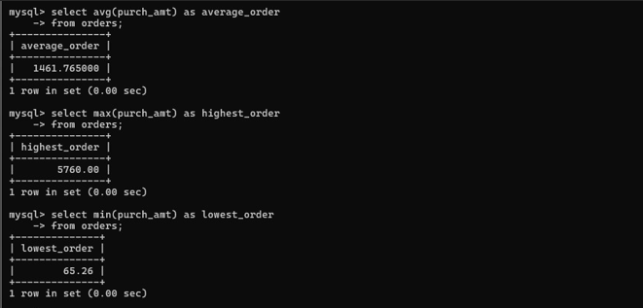
QUESTION 10 - COUNT()
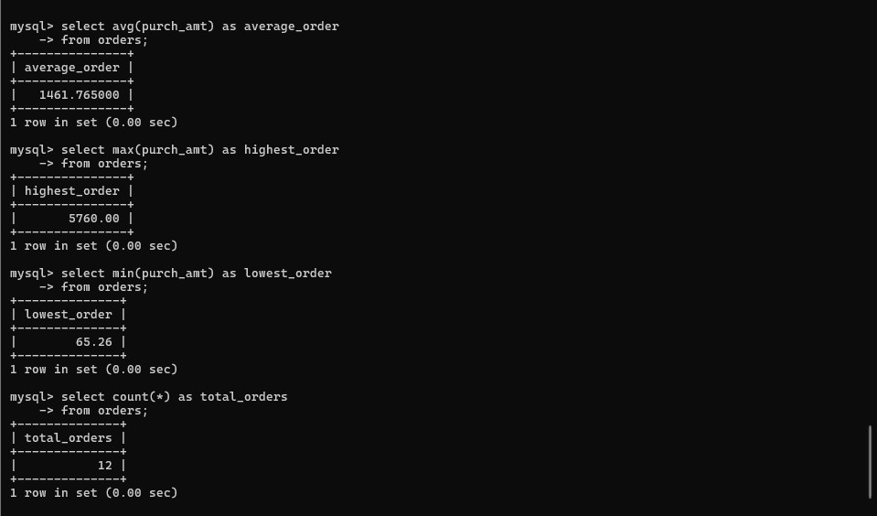

QUESTION 11 GROUP BY
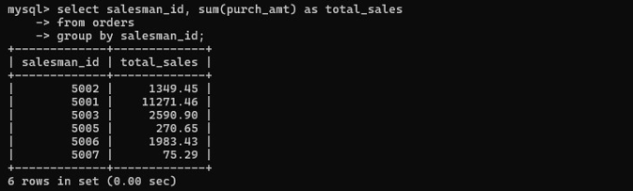
QUESTION 12 - GROUP BY
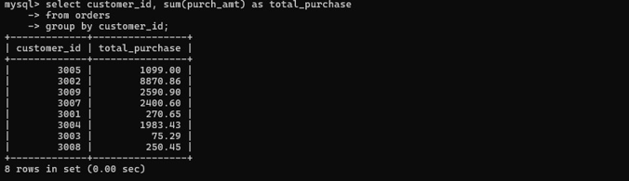
QUESTION 13 - GROUP BY + MAX()
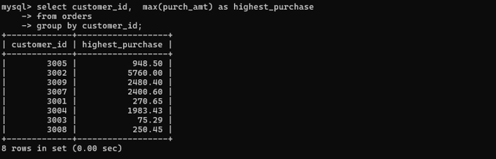
QUESTION 14 - GROUP BY + HAVING
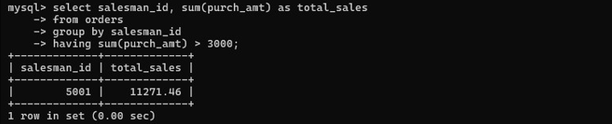

QUESTION 15 GROUP BY + HAVING
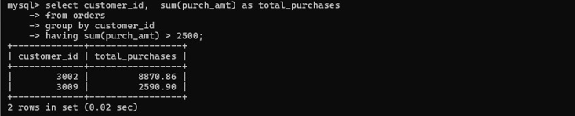
QUESTION 16 - GROUP BY + HAVING
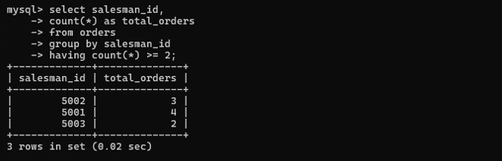

QUESTION 17 - GROUP BY + HAVING + ORDER BY 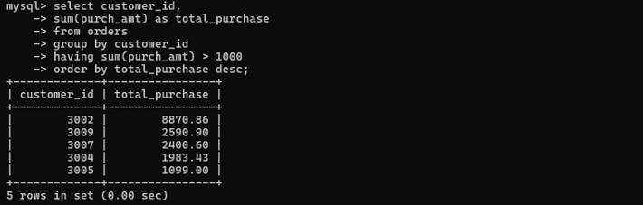

QUESTION 18 - BETWEEN + HAVING
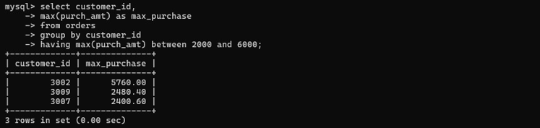

QUESTION 19 COUNT + HAVING
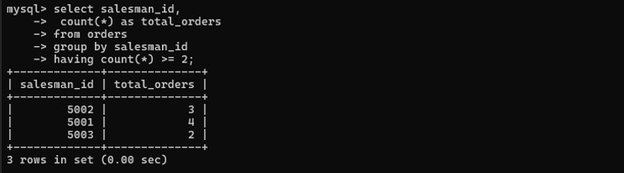
QUESTION 20 - MAX + GROUP BY + HAVING
